|  |  |  |
| --- | --- | --- |
|  | **Project Design Phase-II** | |
|  | **Technology Stack** | |
|  |  |  |
| **Date** |  |  |
|  |  |  |
| **Team ID** |  |  |
|  |  |  |
| **Project** **Name** |  | Early Detection of Chronic Kidney Disease |
|  |  | using Machine Learning |
| **Maximum Marks** |  | 4 Marks |
|  |  |  |

**Technical Architecture:**

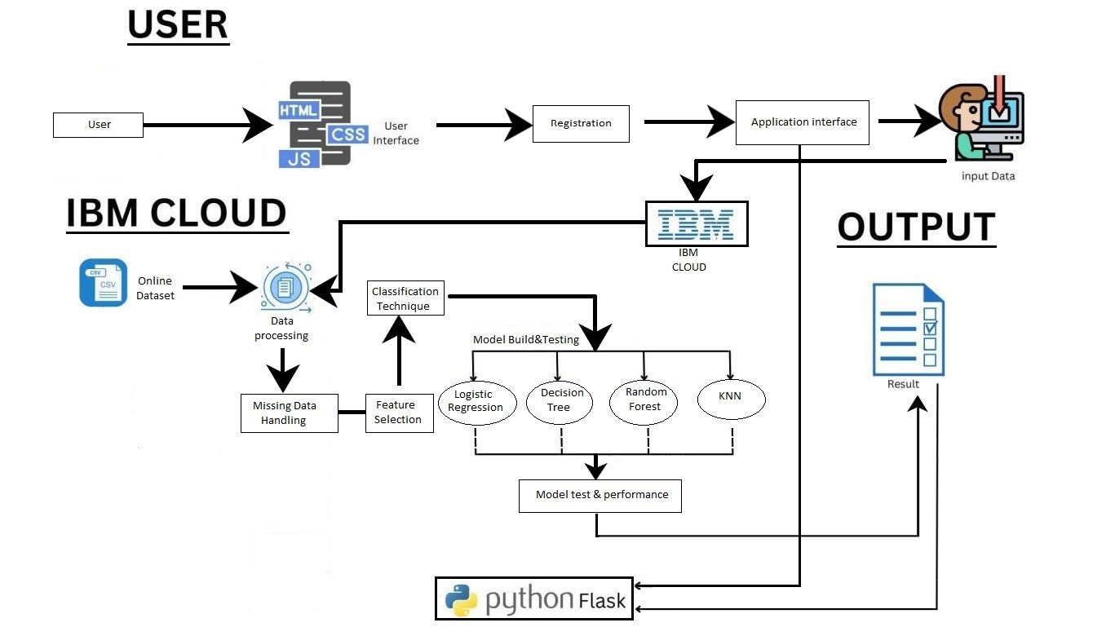

**Table-1 : Components & Technologies:**

|  |  |  |  |
| --- | --- | --- | --- |
| **S.No** | **Component** | **Description** | **Technology** |
|  |  |  |  |
| 1. | User Interface | User to interact with the model. | HTML, CSS, JavaScript. |
|  |  |  |  |
|  |  |  |  |
| 2. | User Registration | User can register in the web | HTML forms |
|  |  | application |  |
| 3. | Disease Prediction | Enters the data | Machine Learning with |
|  |  | which is given as input to | Python. |
|  |  | model to predict the disease. |  |
| 4. | Update Prediction result | The result of disease | Python. |
|  |  | prediction is updated in the |  |
|  |  | Web UI for the user to know |  |
|  |  | the output. |  |
| 5. | Database | Relational database structure | MYSQL. |
|  |  | to store the user data |  |
| 6. | Cloud Database | Database services on IBM | IBM Cloudant. |
|  |  | cloud. |  |
| 7. | Machine Learning Model | To predict the chronic kidney | Random Forest, KNN, |
|  |  | disease (CKD) with various | Decision tree, Logistic |
|  |  | input parameters. | Registration. |
| 8. | Infrastructure (Server / | Application Deployment on | IBM Cloud. |
|  | Cloud) | Cloud |  |
|  |  |  |  |

**Table-2: Application Characteristics:**

|  |  |  |  |
| --- | --- | --- | --- |
| **S.No** | **Characteristics** | **Description** | **Technology** |
|  |  |  |  |
| 1. | Open-Source | The python open-source | Python Flask, Numpy, |
|  | Frameworks | frameworks are used to build | Scikit-Learn etc. |
|  |  | the web application as well as |  |
|  |  | to build Machine Learning |  |
|  |  | model. |  |
| 2. | Scalable Architecture | The 3-tier architecture used | IBM Watson Studio. |
|  |  | with a separate user |  |
|  |  | interface, application tier and |  |
|  |  | data tier make it easily |  |
|  |  | scalable. |  |
| 3. | Availability | The web application is highly | IBM Cloud. |
|  |  | available as it is deployed in |  |
|  |  | cloud. |  |
| 4. | Performance | The performance of the | IBM Cloud Internet |
|  |  | website is improved with | Services. |
|  |  | caching and security. |  |